UNCOVERING THE GAMING INDUSTRY'S HIDDEN GEMS:A COMPREHENSIVE ANALYSIS OF VIDEO GAME SALES

1.INTRODUCTION
1.1 OVERVIEW
Video game sales analysis is the process of collecting and analysing data about the sales of video game in order to understand market trends and consumer bahaviour.This type of analysis can be useful for a vareity of purposes,including identifying the most popular game and genres, predicting future sales and developing marketing strategies.Video game sales analysis typically involves collection data from kaggle sources.It was genereted by a scrape of vgchartz.com.This data may include information about the number of units sold,the retail price, and the platforms on which the games are played.Once the data has been collected,it is typically analysed using tableau.
1.2 PURPOSE
Business requirements for analyzing video game sales would include data on the sales of specific video games, information on the gaming industry as a whole, and data on consumer demographics and purchasing habits.This information can be used to identify trends and make informed decisions on marketing and development strategies for future video game releases. Additionally, it's also important to have information on platform sales, regions and competition in the market.The main purpose of this project is knowing about the video game sales in different regions of the country and it gives more information about the video game.
2.PROBLEM DEFINITION AND DESIGN THINKING
2.1 EMPHATHY MAP
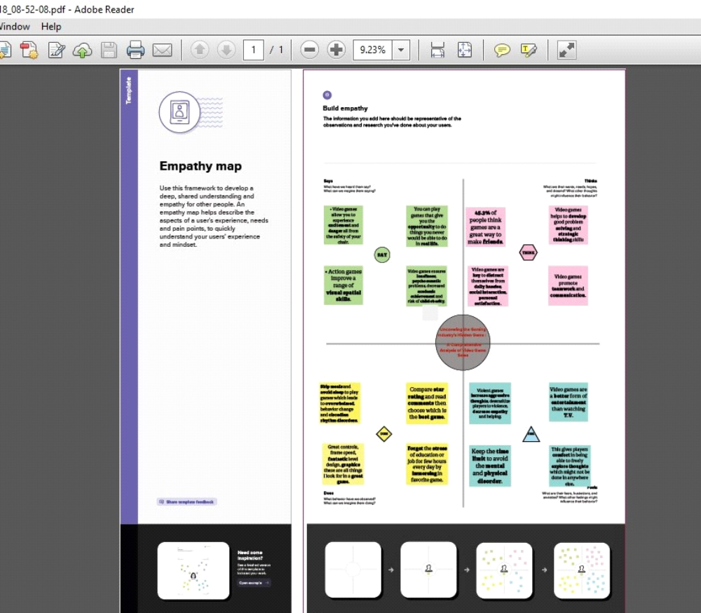

2.2 IDEATION AND BRAINSTORMING MAP
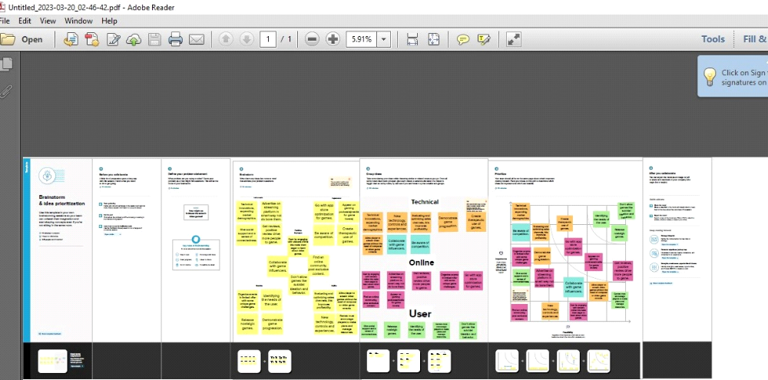

3. RESULT
DASHBOARD
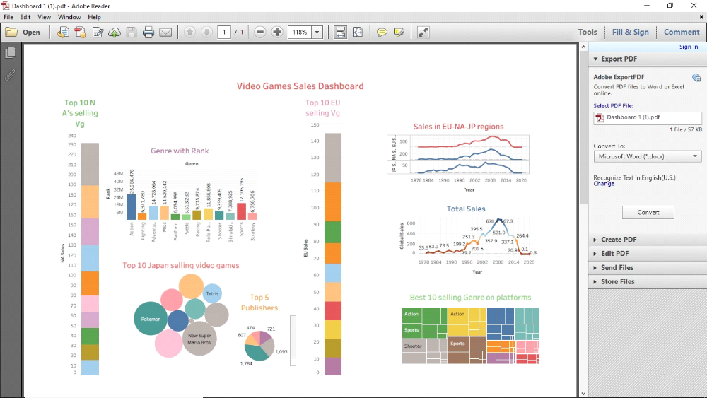
STORY
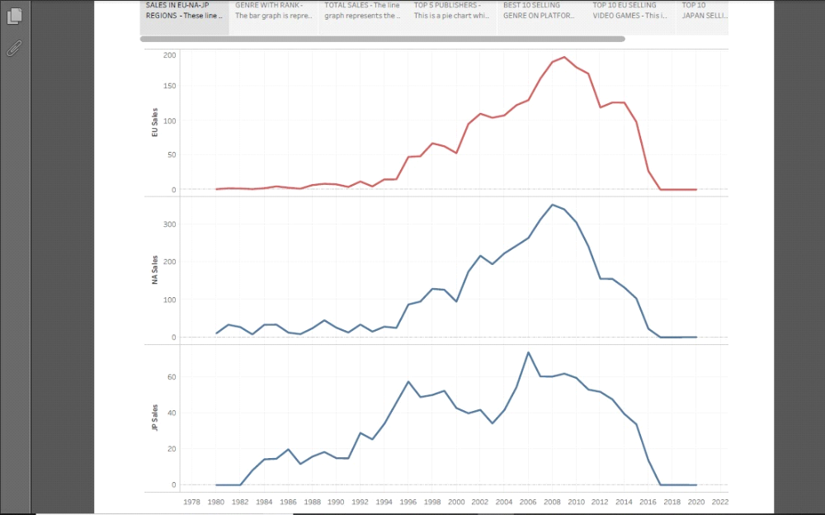

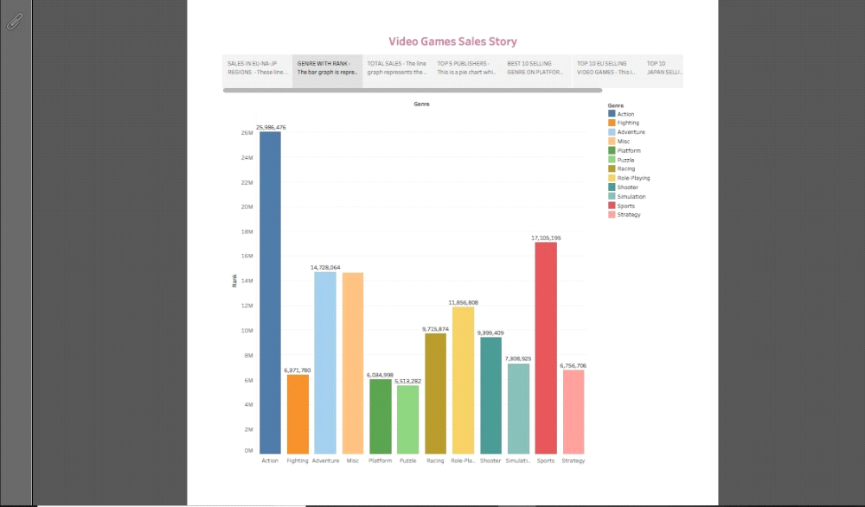
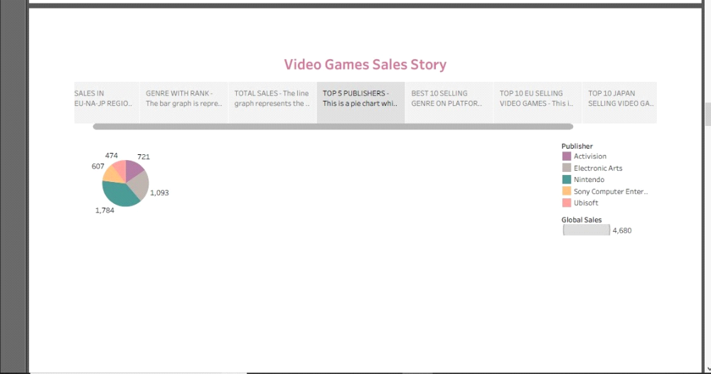
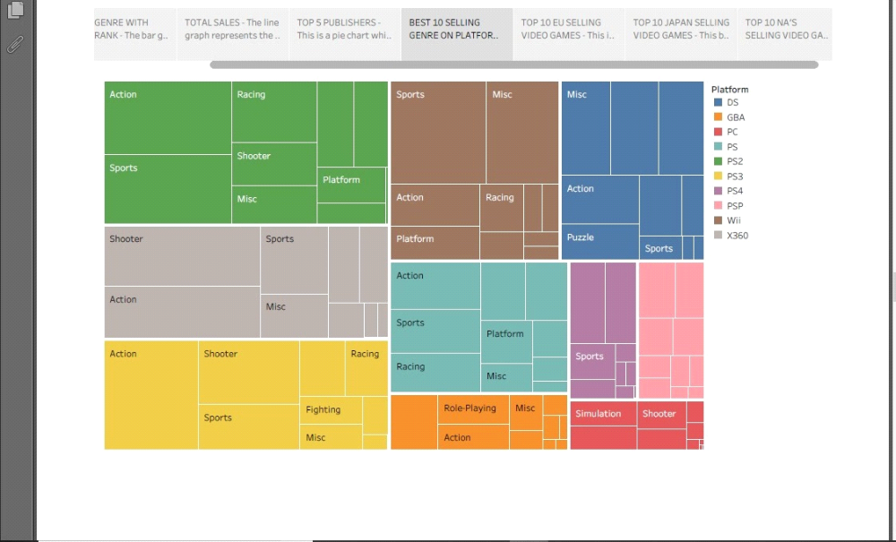
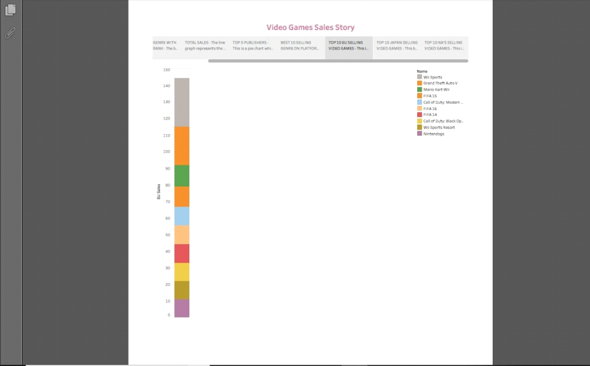
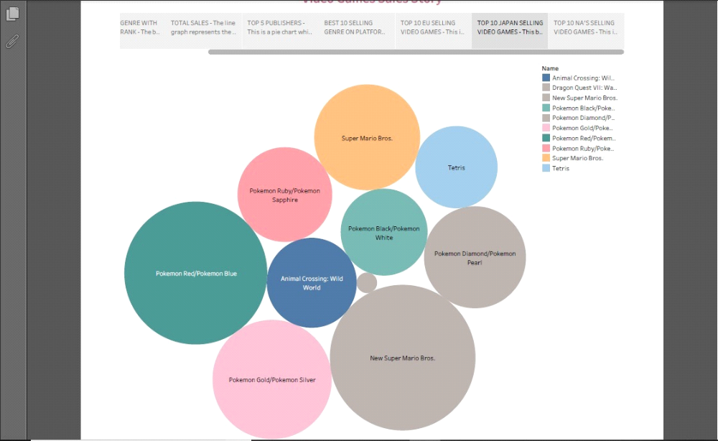
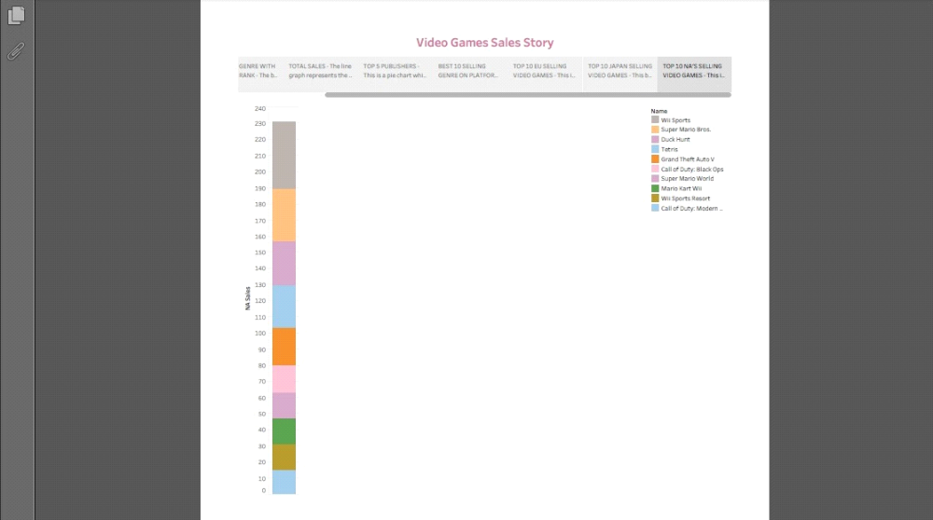
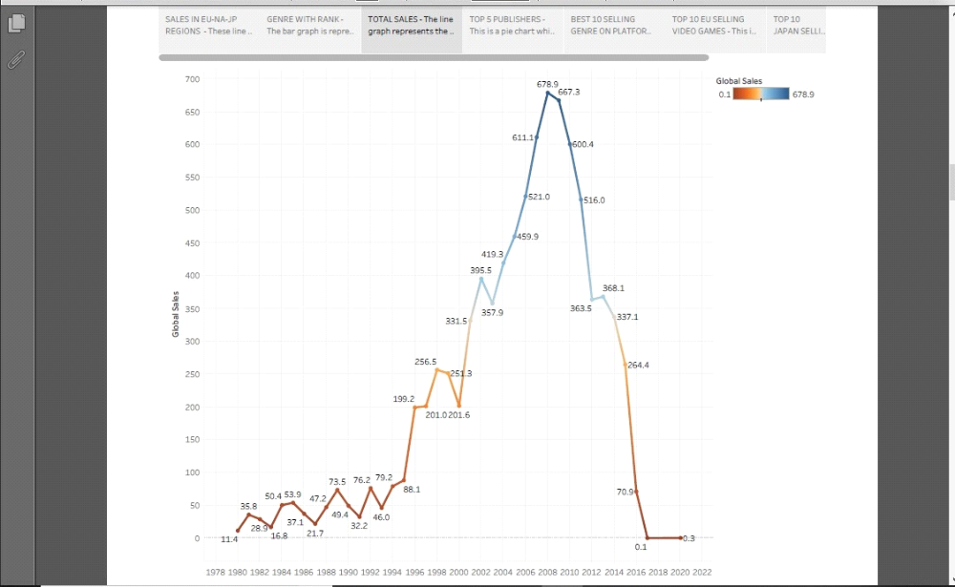
WEB APPLICATIONS

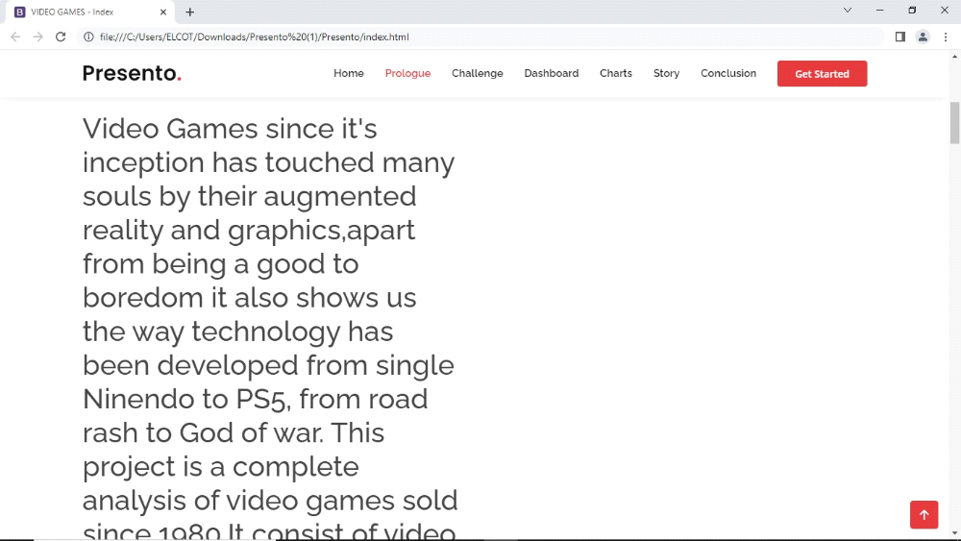
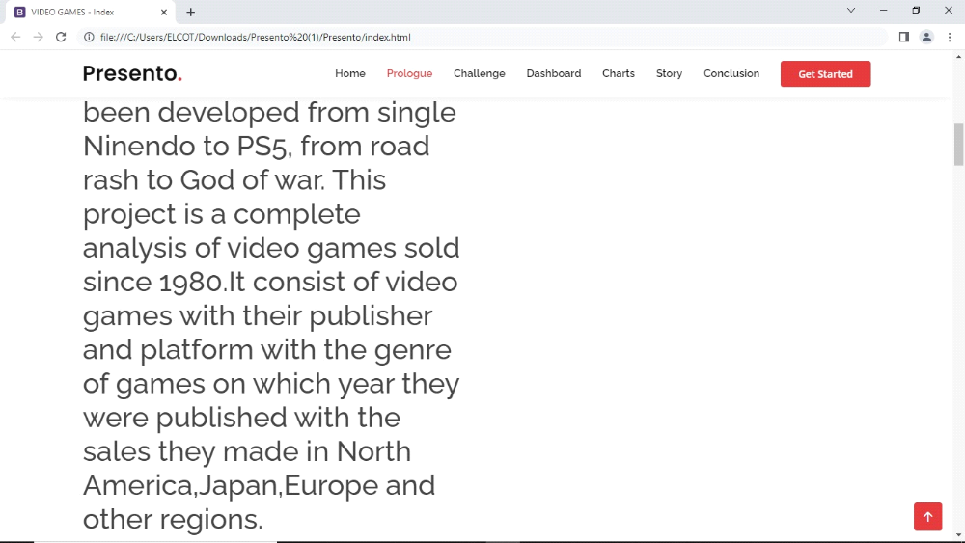
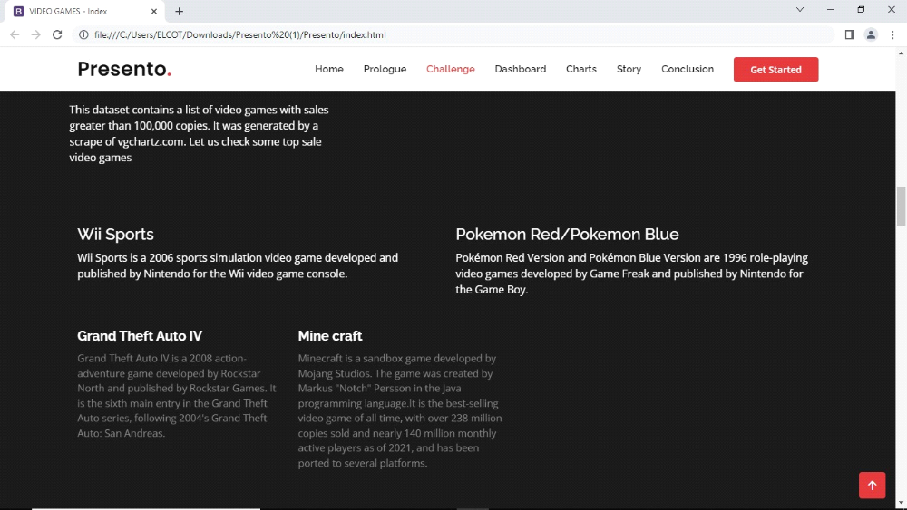
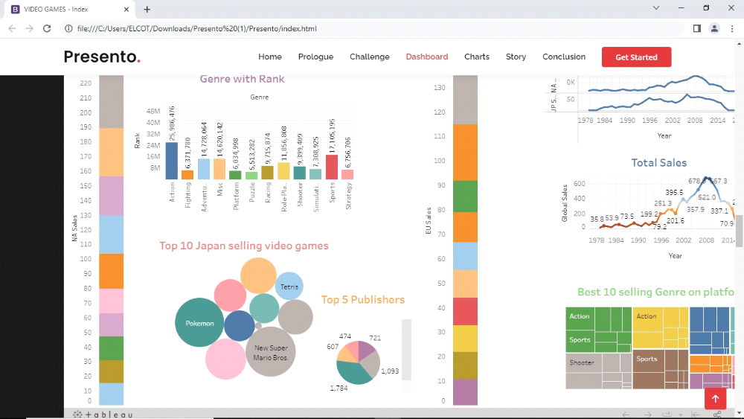
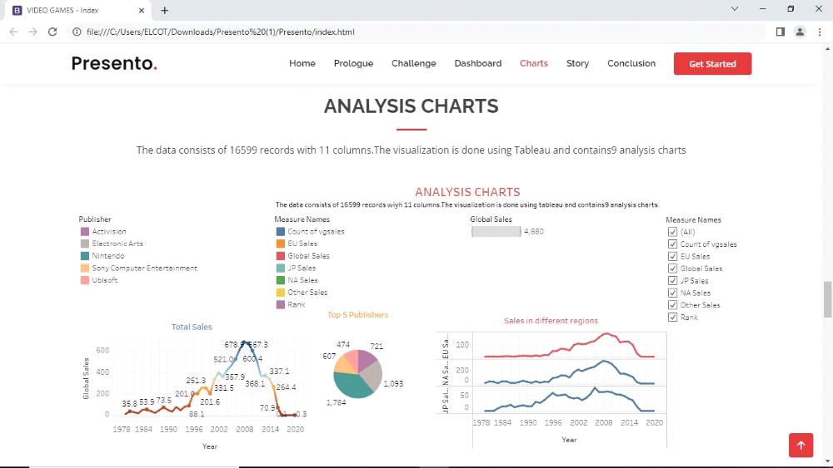
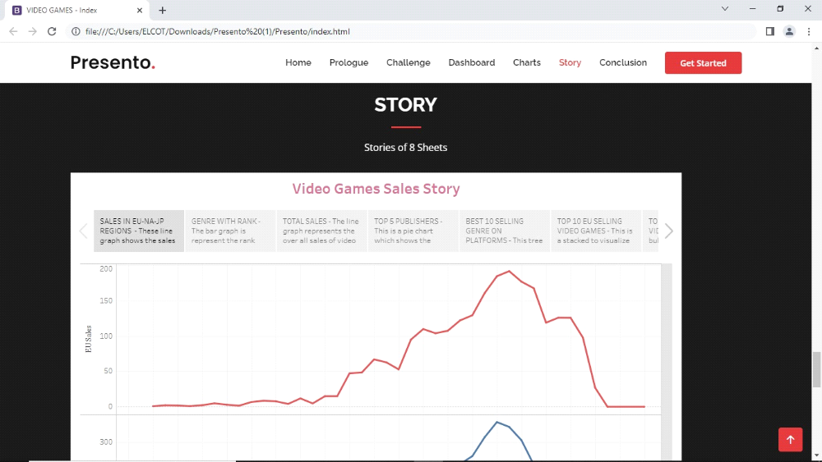
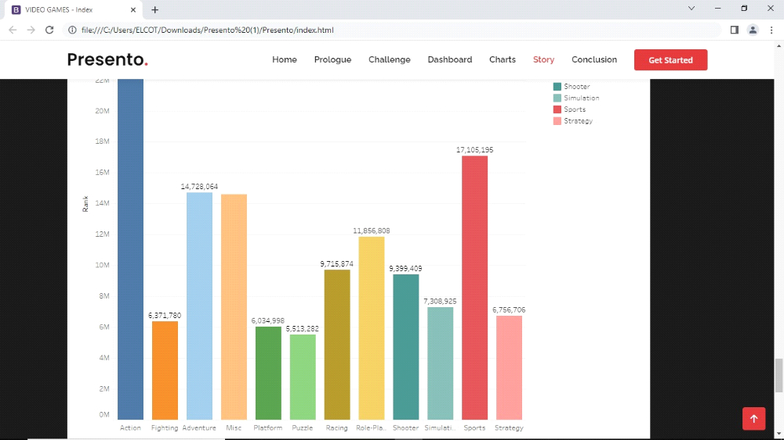
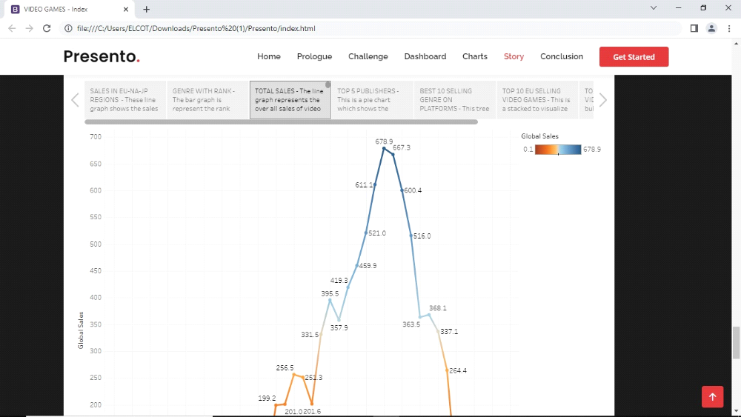
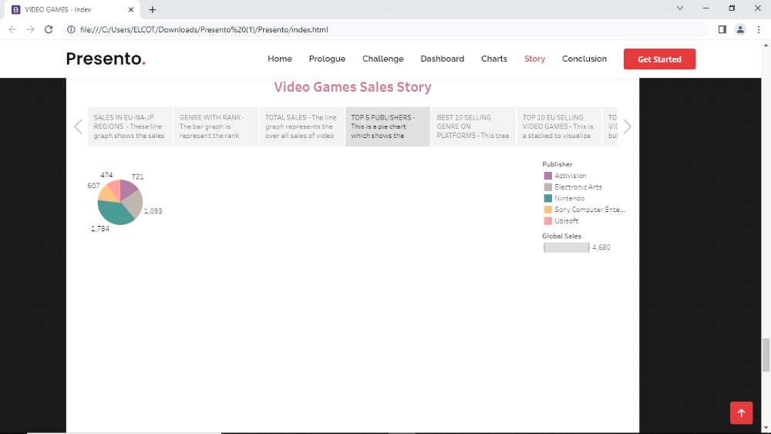
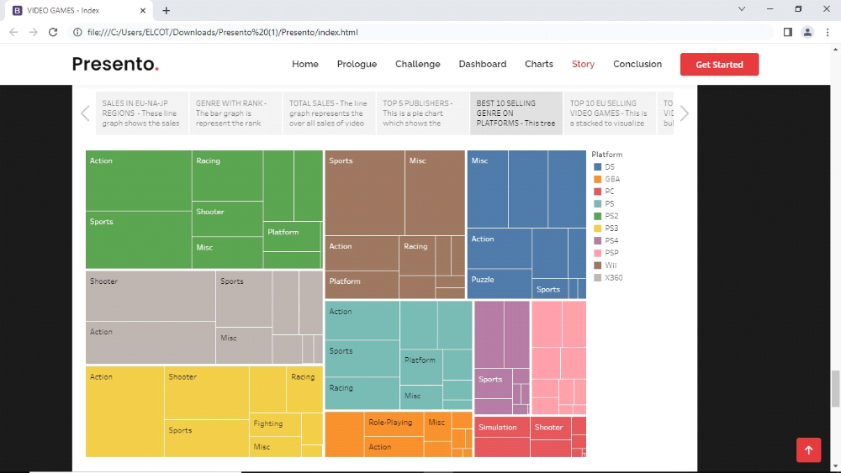
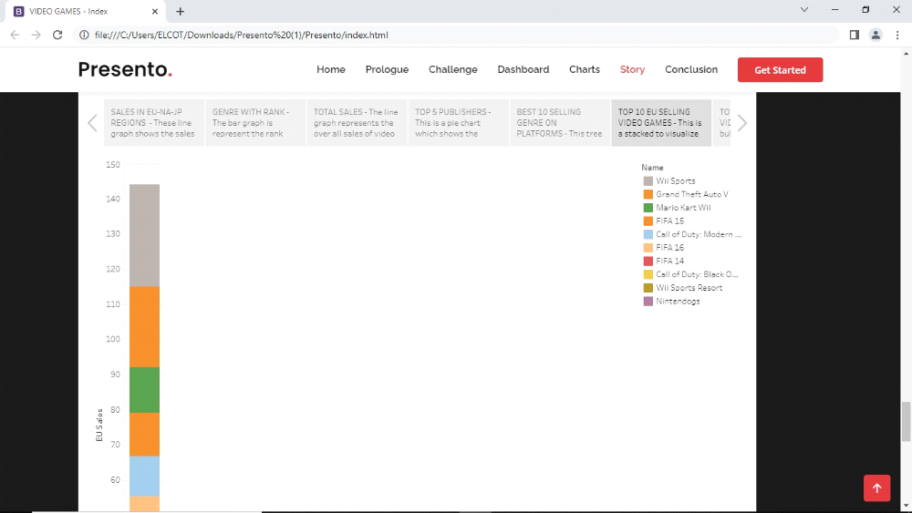
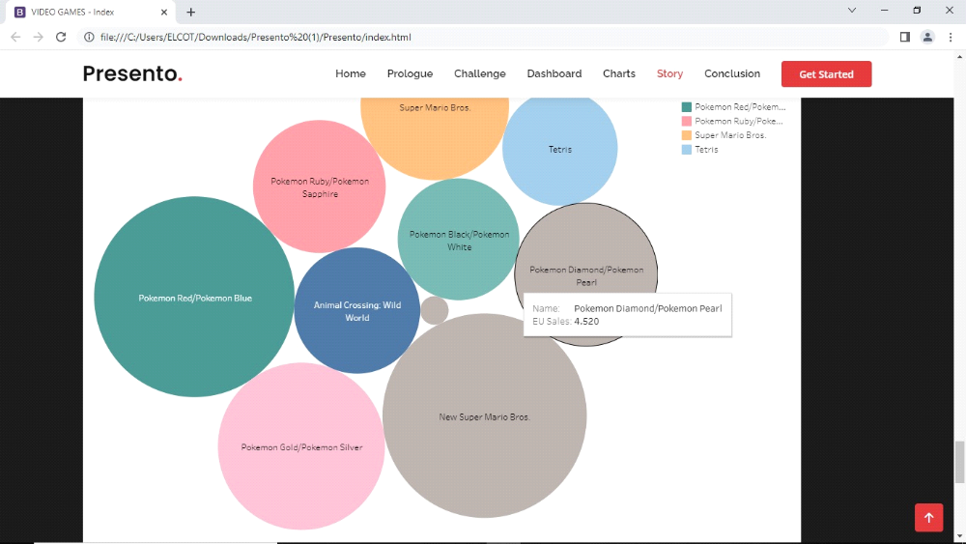
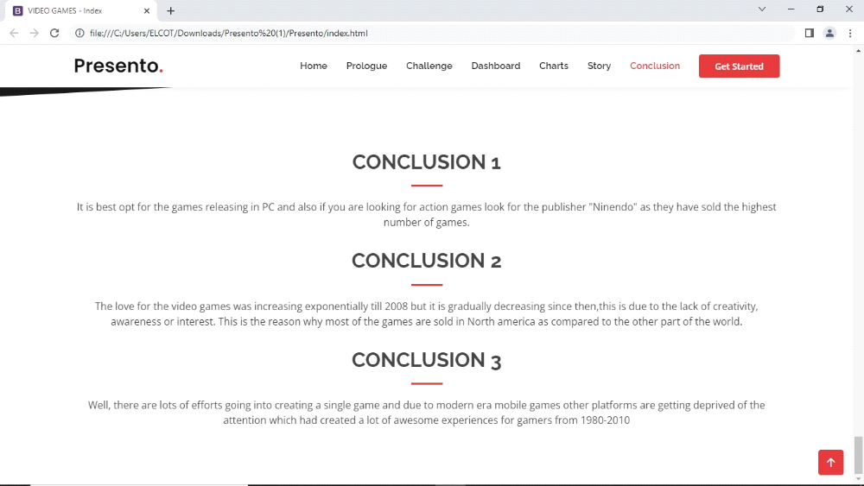

- The results of the analysis can be used to identify trends and patterns in the market, and to make informed decisions about the development and marketing of video game. This analysis may be conducted by game developers, publishers, retailers and other industry professionals.It is an important part of the video game industry, as it helps to understand the needs and preference of consumers and to identify opportunities for growth and innovation.
- From this project we obtain a more details about video game sales by taking a three different regions , by analysing the graph of video games sales rate, are decreasing at now.
- We take the top 10 most video games sales in three different countries there are Japan, North America and Europe.
4 ADVANTAGES AND DISADVANTAGES:
The result shows that the action and sports games are most liked by the people.The advantage of action game is ,they get a ideas of how to solve problems and it improves a range of visual spatial skills.
- Increased social interaction and connection through online multiplier gaming.
- Increased awareness and representation of diverse groups in the gaming industry.
- Increased accessibility to gaming mobile and online platforms.
- Increased use of gaming as a form of therapy of rehabilitation.
The disadvantages of the solution is required to get more information and knowledge about the field.
- By playing action games, the disadvantages of player become very violent behavior.
- They cannot involve real life by enjoying the fantasy one.
- They get addiction in playing video games it leads to suicide.
5. APPLICATION
- It is applied in the field of technology provide a way has been developed from single Ninendo to PS5 , from road rash to God of war.
- Gaming analytics can be best defined as the whole process of applying user behavior data to guide sales and marketing, product enchancements, and business decisions for any gaming company.
- Help developers efficiency,find out potential development problems and polish them instantly.
6.CONCLUSION
- It is the best option for the games releasing in PC and also if you are looking for action games look for the publisher "Ninendo" as they have sold the highest number of games.
- The love for the video games was increasing exponentially till 2008 but it is gradually decreasing since then, this is due to the lack of creativity,awareness or interest.This is the reason why most of the games are sold in North America as compared to the other part of the world.
- Well, there are lots of efforts going into creating a single game and due to modern era mobile games other platforms are getting deprived of the attention which had to created a lot of awesome experiences for gamers from 1980-2010.
7.FUTURE SCOPE
- It enchance the future sale by giving more features, puzzle games are playing only low rate of people, so in this we can improve the designing of games.
- Games Designing is one of the most upcoming course fort students who wanted to make a Game Designer Career in India in animation.
- Consumer demand is growing , technology advanced quickly, and new monetization models are taking off.
- India gaming and experts sectors has witnessed tremendous growth over the past few years, and there is no doubt that this growth will skyrocked even more in the years to come.
- One feature that did come up a lot was removing the need for a console in 2050.
8 APPENDIX
A.SOURCE CODE
<!DOCTYPE html>
<html lang="en">

<head>
<meta charset="utf-8">
<meta content="width=device-width, initial-scale=1.0" name="viewport">

<title>VIDEO GAMES - Index</title>
<meta content="" name="description">
<meta content="" name="keywords">

<!-- Favicons -->
<link href="assets/img/favicon.png" rel="icon">
<link href="assets/img/apple-touch-icon.png" rel="apple-touch-icon">

<!-- Google Fonts -->
<link href="https://fonts.googleapis.com/css?family=Open+Sans:300,300i,400,400i,600,600i,700,700i|Raleway:300,300i,400,400i,500,500i,600,600i,700,700i|Poppins:300,300i,400,400i,500,500i,600,600i,700,700i" rel="stylesheet">

<!-- Vendor CSS Files -->
<link href="assets/vendor/aos/aos.css" rel="stylesheet">
<link href="assets/vendor/bootstrap/css/bootstrap.min.css" rel="stylesheet">
<link href="assets/vendor/bootstrap-icons/bootstrap-icons.css" rel="stylesheet">
<link href="assets/vendor/boxicons/css/boxicons.min.css" rel="stylesheet">
<link href="assets/vendor/glightbox/css/glightbox.min.css" rel="stylesheet">
<link href="assets/vendor/remixicon/remixicon.css" rel="stylesheet">
<link href="assets/vendor/swiper/swiper-bundle.min.css" rel="stylesheet">

<!-- Template Main CSS File -->
<link href="assets/css/style.css" rel="stylesheet">

<!-- =======================================================
* Template Name: Presento
* Updated: Mar 10 2023 with Bootstrap v5.2.3
* Template URL: https://bootstrapmade.com/presento-bootstrap-corporate-template/
* Author: BootstrapMade.com
* License: https://bootstrapmade.com/license/
======================================================== -->
</head>

<body>

<!-- ======= Header ======= -->
<header id="header" class="fixed-top d-flex align-items-center">
<div class="container d-flex align-items-center">
<h1 class="logo me-auto"><a href="index.html">Presento<span>.</span></a></h1>
<!-- Uncomment below if you prefer to use an image logo -->
<!-- <a href="index.html" class="logo me-auto"><img src="assets/img/logo.png" alt=""></a>-->

<nav id="navbar" class="navbar order-last order-lg-0">
<ul>
<li><a class="nav-link scrollto active" href="#hero">Home</a></li>
<li><a class="nav-link scrollto" href="#head">Prologue</a></li>
<li><a class="nav-link scrollto" href="#about">Challenge</a></li>
<li><a class="nav-link scrollto " href="#services">Dashboard</a></li>
<li><a class="nav-link scrollto" href="#portfolio">Charts</a></li>
<li><a class="nav-link scrollto" href="#team">Story</a></li>
<li><a class="nav-link scrollto" href="#contact">Conclusion</a></li>

</ul>
<i class="bi bi-list mobile-nav-toggle"></i>
</nav><!-- .navbar -->

<a href="#about" class="get-started-btn scrollto">Get Started</a>
</div>
</header><!-- End Header -->

<!-- ======= Hero Section ======= -->
<section id="hero" class="d-flex align-items-center">

<div class="container" data-aos="zoom-out" data-aos-delay="100">
<div class="row">
<div class="col-xl-6">
<h1>A Tableau Presentation</h1>
<a href="#about" class="btn-get-started scrollto">Get Started</a>
</div>
</div>
</div>

</section><!-- End Hero -->
<!-- ======= Head Section ======= -->
<section id="head" class="d-flex align-items-fill">

<div class="container" data-aos="zoom-out" data-aos-delay="100">
<div class="row">
<div class="col-xl-6">
<h1>Video Games since it's inception has touched many souls by their augmented reality and
graphics,apart from being a good to boredom it also shows us the way technology has been
developed from single Ninendo to PS5, from road rash to God of war.
This project is a complete analysis of video games sold since 1980.It consist of video games
with their publisher and platform with the genre of games on which year they were published
with the sales they made in North America,Japan,Europe and other regions.</h1>>
</div>
</div>
</div>

</section><!-- End Hero -->

<main id="main">

<!-- ======= Clients Section ======= -->
<section id="clients" class="clients">
<div class="container" data-aos="zoom-in">

<div class="clients-slider swiper">
<div class="swiper-wrapper align-items-center">
<div class="swiper-slide"><img src="assets/img/clients/client-1.png" class="img-fluid" alt=""></div>
<div class="swiper-slide"><img src="assets/img/clients/client-2.png" class="img-fluid" alt=""></div>
<div class="swiper-slide"><img src="assets/img/clients/client-3.png" class="img-fluid" alt=""></div>
<div class="swiper-slide"><img src="assets/img/clients/client-4.png" class="img-fluid" alt=""></div>
<div class="swiper-slide"><img src="assets/img/clients/client-5.png" class="img-fluid" alt=""></div>
<div class="swiper-slide"><img src="assets/img/clients/client-6.png" class="img-fluid" alt=""></div>
<div class="swiper-slide"><img src="assets/img/clients/client-7.png" class="img-fluid" alt=""></div>
<div class="swiper-slide"><img src="assets/img/clients/client-8.png" class="img-fluid" alt=""></div>
</div>
<div class="swiper-pagination"></div>
</div>

</div>
</section><!-- End Clients Section -->

<!-- ======= About Section ======= -->
<section id="about" class="about section-bg">
<div class="container" data-aos="fade-up">

<div class="row no-gutters">
<div class="content col-xl-5 d-flex align-items-stretch">
<div class="content">
<h3>Analysing sales data from more than 16,500 games.</h3>
<p> This dataset contains a list of video games
with sales greater than 100,000 copies. It was generated by a scrape of vgchartz.com.
Let us check some top sale video games
</p>
</div>
</div>
<div class="col-md-6 icon-box" data-aos="fade-up" data-aos-delay="100">
<h4>Super Mario Bros</h4>
<p>Super Mario Bros is a platform game developed and published by Nintendo for the Nintendo
Entertainment System(NES).</p>
</div>
<div class="col-md-6 icon-box" data-aos="fade-up" data-aos-delay="100">
<h4>Wii Sports</h4>
<p>Wii Sports is a 2006 sports simulation video game developed and published by Nintendo for the
Wii video game console.</p>
</div>
<div class="col-md-6 icon-box" data-aos="fade-up" data-aos-delay="100">
<h4>Pokemon Red/Pokemon Blue</h4>
<p>Pokémon Red Version and Pokémon Blue Version are 1996 role-playing video games
developed by Game Freak and published by Nintendo for the Game Boy.</p>
</div>

<div class="col-xl-7 d-flex align-items-stretch">
<div class="icon-boxes d-flex flex-column justify-content-center">
<div class="row">
<div class="col-md-6 icon-box" data-aos="fade-up" data-aos-delay="200">
<h4>Grand Theft Auto IV</h4>
<p>Grand Theft Auto IV is a 2008 action-adventure game developed by Rockstar North and
published by Rockstar Games. It is the sixth main entry in the Grand Theft Auto series, following
2004's Grand Theft Auto: San Andreas.</p>
</div>
<div class="col-md-6 icon-box" data-aos="fade-up" data-aos-delay="300">
<h4>Mine craft</h4>
<p>Minecraft is a sandbox game developed by Mojang Studios. The game was created by Markus
"Notch" Persson in the Java programming language.It is the best-selling video game of all time,
with over 238 million copies sold and nearly 140 million monthly active players as of 2021, and
has been ported to several platforms.</p>
</div>
<div class="col-md-6 icon-box" data-aos="fade-up" data-aos-delay="400">
<h4>FIFA 16</h4>
<p>FIFA 16 is a football simulation video game developed by EA Canada and published by
Electronic Arts under the EA Sports label.</p>
</div>
</div>
</div><!-- End .content-->
</div>
</div>

</div>
</section><!-- End About Section -->

</section><!-- End Tabs Secti-->on

<!-- ======= Services Section ======= -->
<section id="services" class="services section-bg ">
<div class="container" data-aos="fade-up">

<div class="section-title">
<h2>Dashboard</h2>
<p>There you go!!This dashboard contains 8 main analysis charts</p>
</div><div class='tableauPlaceholder' id='viz1681307939968' style='position: relative'><noscript><a href='#'><img alt='Video Games Sales Dashboard ' src='https:&#47;&#47;public.tableau.com&#47;static&#47;images&#47;VG&#47;VGPROJECT&#47;Dashboard1&#47;1_rss.png' style='border: none' /></a></noscript><object class='tableauViz' style='display:none;'><param name='host_url' value='https%3A%2F%2Fpublic.tableau.com%2F' /> <param name='embed_code_version' value='3' /> <param name='site_root' value='' /><param name='name' value='VGPROJECT&#47;Dashboard1' /><param name='tabs' value='no' /><param name='toolbar' value='yes' /><param name='static_image' value='https:&#47;&#47;public.tableau.com&#47;static&#47;images&#47;VG&#47;VGPROJECT&#47;Dashboard1&#47;1.png' /> <param name='animate_transition' value='yes' /><param name='display_static_image' value='yes' /><param name='display_spinner' value='yes' /><param name='display_overlay' value='yes' /><param name='display_count' value='yes' /><param name='language' value='en-US' /></object></div> <script type='text/javascript'> var divElement = document.getElementById('viz1681307939968'); var vizElement = divElement.getElementsByTagName('object')[0]; if ( divElement.offsetWidth > 800 ) { vizElement.style.width='1300px';vizElement.style.height='827px';} else if ( divElement.offsetWidth > 500 ) { vizElement.style.width='1300px';vizElement.style.height='827px';} else { vizElement.style.width='100%';vizElement.style.height='2077px';} var scriptElement = document.createElement('script'); scriptElement.src = 'https://public.tableau.com/javascripts/api/viz_v1.js'; vizElement.parentNode.insertBefore(scriptElement, vizElement); </script>

</div>

</div>
</section><!-- End Services Section -->

<!-- ======= Portfolio Section ======= -->
<section id="portfolio" class="portfolio">
<div class="container" data-aos="fade-up">

<div class="section-title">
<h2>ANALYSIS CHARTS</h2>
<p>The data consists of 16599 records with 11 columns.The visualization is done using Tableau and contains9 analysis charts</p>
</div>
<div class='tableauPlaceholder' id='viz1681308933763' style='position: relative'><noscript><a href='#'><img alt='ANALYSIS CHARTSThe data consists of 16599 records wiyh 11 columns.The visualization is done using tableau and contains9 analysis charts. ' src='https:&#47;&#47;public.tableau.com&#47;static&#47;images&#47;An&#47;AnalysisCharts&#47;Dashboard2&#47;1_rss.png' style='border: none' /></a></noscript><object class='tableauViz' style='display:none;'><param name='host_url' value='https%3A%2F%2Fpublic.tableau.com%2F' /> <param name='embed_code_version' value='3' /> <param name='site_root' value='' /><param name='name' value='AnalysisCharts&#47;Dashboard2' /><param name='tabs' value='no' /><param name='toolbar' value='yes' /><param name='static_image' value='https:&#47;&#47;public.tableau.com&#47;static&#47;images&#47;An&#47;AnalysisCharts&#47;Dashboard2&#47;1.png' /> <param name='animate_transition' value='yes' /><param name='display_static_image' value='yes' /><param name='display_spinner' value='yes' /><param name='display_overlay' value='yes' /><param name='display_count' value='yes' /><param name='language' value='en-US' /></object></div> <script type='text/javascript'> var divElement = document.getElementById('viz1681308933763'); var vizElement = divElement.getElementsByTagName('object')[0]; if ( divElement.offsetWidth > 800 ) { vizElement.style.width='1300px';vizElement.style.height='1127px';} else if ( divElement.offsetWidth > 500 ) { vizElement.style.width='1300px';vizElement.style.height='1127px';} else { vizElement.style.width='100%';vizElement.style.height='2477px';} var scriptElement = document.createElement('script'); scriptElement.src = 'https://public.tableau.com/javascripts/api/viz_v1.js'; vizElement.parentNode.insertBefore(scriptElement, vizElement); </script>

</div>

</div>
</section><!-- End Portfolio Section -->

<!-- ======= Team Section ======= -->
<section id="team" class="team section-bg">
<div class="container" data-aos="fade-up">

<div class="section-title">
<h2>Story</h2>
<p>Stories of 8 Sheets</p>
</div><div class='tableauPlaceholder' id='viz1681309161900' style='position: relative'><noscript><a href='#'><img alt='Video Games Sales Story ' src='https:&#47;&#47;public.tableau.com&#47;static&#47;images&#47;Vi&#47;VideoGamesSalesStory_16810286529650&#47;Story1&#47;1_rss.png' style='border: none' /></a></noscript><object class='tableauViz' style='display:none;'><param name='host_url' value='https%3A%2F%2Fpublic.tableau.com%2F' /> <param name='embed_code_version' value='3' /> <param name='site_root' value='' /><param name='name' value='VideoGamesSalesStory_16810286529650&#47;Story1' /><param name='tabs' value='no' /><param name='toolbar' value='yes' /><param name='static_image' value='https:&#47;&#47;public.tableau.com&#47;static&#47;images&#47;Vi&#47;VideoGamesSalesStory_16810286529650&#47;Story1&#47;1.png' /> <param name='animate_transition' value='yes' /><param name='display_static_image' value='yes' /><param name='display_spinner' value='yes' /><param name='display_overlay' value='yes' /><param name='display_count' value='yes' /><param name='language' value='en-US' /></object></div> <script type='text/javascript'> var divElement = document.getElementById('viz1681309161900'); var vizElement = divElement.getElementsByTagName('object')[0]; vizElement.style.width='1016px';vizElement.style.height='991px'; var scriptElement = document.createElement('script'); scriptElement.src = 'https://public.tableau.com/javascripts/api/viz_v1.js'; vizElement.parentNode.insertBefore(scriptElement, vizElement); </script>

</div>

</div>
</section><!-- End Team Section -->

<!-- ======= Contact Section ======= -->
<section id="contact" class="contact">
<div class="container" data-aos="fade-up">

<div class="section-title">
<h2>Conclusion 1</h2>
<p>It is best opt for the games releasing in PC and also if you are looking for action games
look for the publisher "Ninendo" as they have sold the highest number of games.</p>
</div>
<div class="section-title">
<h2>Conclusion 2</h2>
<P>The love for the video games was increasing exponentially till 2008 but it is gradually
decreasing since then,this is due to the lack of creativity, awareness or interest. This is the
reason why most of the games are sold in North america as compared to the other part of
the world.</p>
</div>
<div class="section-title">
<h2>Conclusion 3</h2>
<p>Well, there are lots of efforts going into creating a single game and due to modern era
mobile games other platforms are getting deprived of the attention which had created a lot
of awesome experiences for gamers from 1980-2010</p>
</div>

</div>
</section><!-- End Contact Section -->

</main><!-- End #main -->

<a href="#" class="back-to-top d-flex align-items-center justify-content-center"><i class="bi bi-arrow-up-short"></i></a>

<!-- Vendor JS Files -->
<script src="assets/vendor/purecounter/purecounter_vanilla.js"></script>
<script src="assets/vendor/aos/aos.js"></script>
<script src="assets/vendor/bootstrap/js/bootstrap.bundle.min.js"></script>
<script src="assets/vendor/glightbox/js/glightbox.min.js"></script>
<script src="assets/vendor/isotope-layout/isotope.pkgd.min.js"></script>
<script src="assets/vendor/swiper/swiper-bundle.min.js"></script>
<script src="assets/vendor/php-email-form/validate.js"></script>

<!-- Template Main JS File -->
<script src="assets/js/main.js"></script>

</body>

</html>

